


Committee on Committees Minutes

Associated Students
DATE: February 2nd, 2026
LOCATION: Pardall Center Minutes/Actions recorded by: Shuyi Sum

CALL TO ORDER: 6:15 by Lily Strange, Internal Chair

QOTW: What is your favorite part of winter quarter at UCSB?

A. MEETING BUSINESS

- Roll Call

Name | Note:  absent (excused/not excused)  arrived late (time)  departed early (time)  proxy (full name) | Name | Note:  absent (excused/not excused)  arrived late (time)  departed early (time)  proxy (full name)
Sophia Fei | Present | Yeshua Valdez Rodriguez | Excused
Lily Strange | Present | Savanah Lizet Aldaba | Present
Shuyi Sum | Present | Adam Orenstein | ...
Oliver Ramirez Carrera | Present | Rylee Bones | Present
Layla Hakim | Excused | Archish Prakhya | Excused
Mira Ikladious | Present

- Acceptance of Excused Absences

MOTION/SECOND: Sophia/Shuyi
Motion Language: I motion to excuse Yeshua, Archish, and Layla from today’s meeting.
ACTION: Consent

- Acceptance of Proxies

B. PUBLIC FORUM

- EXTERNAL REPORTS

- Advisor’s Report

- Executive Officer’s Report(s)

- Group Project/Member Report(s)
  - Advisor and Senate Liaison Reports

Lily Strange - Internal Chair
    - QOTW: three day weekends!
    - Updates on:
      - Career services event
      - Website
      - Liaison committee hiring
      - AS squid games
      - Honoraria
        - Sophia and I submit a form to evaluate all of you and checks should be cut week 7 of winter quarter (for fall honoraria)
      - Board retreat next monday 2/9, meet at 6pm at the bus loop FORMAL ATTIRE

Sophia Fei - External Chair
    - Hanging out with my friends 😀
    - Requisitions
    - update on honoraria
    - Committees cafe updates

Shuyi Sum - Vice Chair
    - QOTW: past answer would be using rain as an excuse to skip class, idk what’s going on with the 80 degrees this week
    - Signed requisitions 👍
    - Liaison Committee applicants didn’t sign up for an interview time slot :(
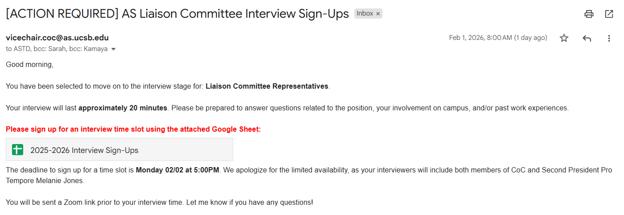
update:
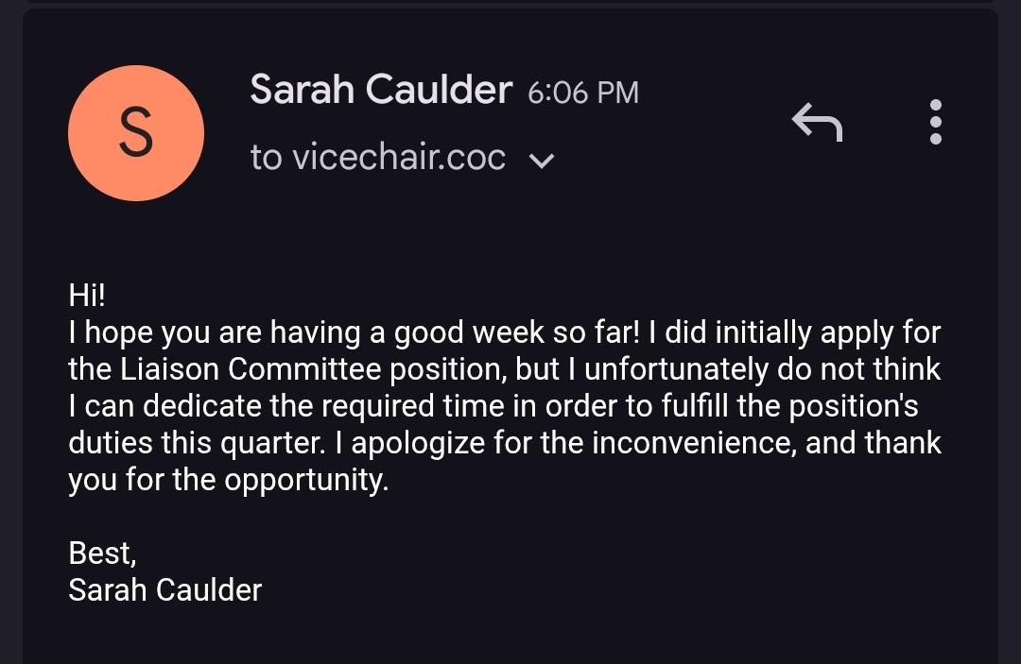
    - RSVP’ed for AS Quarterly Banquet (Feb 10th)
    - I like the restaurant Yeshua recommended last week (Arnoldi’s) for retreat dinner !!

Oliver Ramirez Carrera - Internal Liaison
    - QOTW: My favorite part of the winter quarter at UCSB is watching the weather change from winter to spring
    - Contacted Keizo and introduced myself, not much has happened beyond that, but I’ll keep you guys updated w/ process towards creating the legal code
    - 2nd meeting of the quarter for CEC, same old stuff, discussed voter language, etc. I think we only have a meeting left for the rest of the quarter

Rylee Bones - Internal Liaison
i. QOTW: My favorite part of winter quarter is the weather. I love that it isn’t super hot or sunny because I like the cold
ii. Need to organize committees cafe event and get the supplies
iii. Reach out to committees on tabling with our coffee

Layla Hakim - Outreach and Recruitment Coordinators
    - QOTW: only having one final exam to study for🙏
    - Savanah and I have been working on our event and its almost all set to go!
      - 11-12:45 in pardall on the 11th please come!
      - Added the flier to the promotional folder in the drive
      - It’s probably going to just be a more chill outreach event but we’ll have fliers with open positions out on the table and we’ll speak a bit about CoC
      - Going to post on the insta with the flier tonight
      - Ordered supplies from amazon - is there a specific time I should put in a requisition request? Also how would I go about this without a physical receipt - would a screenshot work?
      - Also do we have a specific budget for it?

Mira Ikladious - Outreach and Recruitment Coordinators
  - Fav part of WQ is the sun being out
  - Posted for 4 open BCUs
  - contacted all BCUs that I posted for to see how they wanted to be advertised
  - Hopefully planning coffee event

Yeshua Valdez Rodriguez - Outreach and Recruitment Coordinators

Savanah Lizet Aldaba - Outreach and Recruitment Coordinators
    - QOTW: My favorite part of winter quarter at UCSB would have to be the warm weather.
    - Last week- Coffee with the President was great!
      - I can attest as witness - Shuyi
    - This week- finalizing Layla and I’s pipe cleaner bouquet event
      - Will print out fliers for our event and post them around campus
      - Going to purchase snacks

Archish Prakhya - Pearman

Adam Orenstein - Commissioner of Community and Climate

C. Action Items

- ACCEPTANCE of AGENDA/CHANGES to AGENDA

- CONSENT ITEMS

- Approval of our Action Summary/Minutes from:

- ACTION ITEMS

F-1. Old Business:

F-2 New Business:
MOTION/SECOND: Lily/Rylee
Motion Language: Motion to pass $200 for the Committees Cafe event on Thursday 2/9/2026. Arbor tabling for Alanis and Costco pastries.
ACTION: CONSENT

- DISCUSSION ITEMS

- Discussion Topic

- REMARKS

- ADJOURNMENT

MOTION/SECOND: Oliver/Sophia
Motion Language: Motion to adjourn this meeting at 7:47pm.
ACTION: CONSENT

